

Judges Lodgings 400 - Voices from Our Community
Oral History Project

Information for Potential Contributors

In 2025, the Judges' Lodgings Museum is celebrating 400 years of being the oldest townhouse in Lancaster and 50 years of operation as a museum by Lancashire County Council. As part of this project, we are seeking to talk to people with memories and experience of the Judges Lodgings. We are interested in hearing about any aspect of the site’s history. We want to share personal stories if you or your family had a connection with this building and the people who worked here. This project is supported by the National Lottery thanks to National Lottery players

Aims of the research
This research aims to record the memories of anyone with an association or experience of the Judges Lodgings. This will help us develop our understanding of how the site operated and contribute to new displays and as a source for future research. We are especially keen to talk to anyone that might have memories of the Judges' Lodgings up until 1975.

What will taking part involve?
Participation will involve an interview conducted by one or two of our researchers. This can take place at the Judges Lodgings (or via online video conferencing if preferred) and will last approximately 60 minutes. Our researchers may also visit you at home where you are of course welcome to have a family member or friend with you. The interview will cover your experiences of the Judges Lodgings in any capacity. With your permission, the interview will be audio-recorded to ensure accurate documentation of your insights.

You and your data (GDPR)
To help us comply with data security legislation, we will also ask you to complete a short consent form giving us permission to store some personal details and allow your recording to be used to inform the project and as a resource for future researchers. Your interview will be stored at the Lancashire Archives in Preston.

Do you have to take part?
Participation is completely voluntary. You have the right to refuse participation, decline to answer any question, and withdraw from the study at any time without providing a reason and without any negative consequences whatsoever.

How will the information you provide be recorded, stored and protected?
Interviews will be audio-recorded and transcribed. All electronic data will be stored on password-protected devices. Physical documents including consent forms will be kept in locked cabinets in secure facilities accessible only to the research team. Signed consent forms, original audio recordings, and transcripts of interviews will be deposited at Lancashire Archive in Preston where they will be catalogued and eventually made available to future researchers.

Timescale
The project runs until the summer of 2026. We aim to interview participants between December 2025 and April 2026.

Who should you contact for further information?
For further information, please contact us on 01524 581241 (Tuesday to Friday) or email us at judgeslodgings@lancashire.gov.uk.

Thank you for taking the time to read this information sheet and for considering participation in this research.

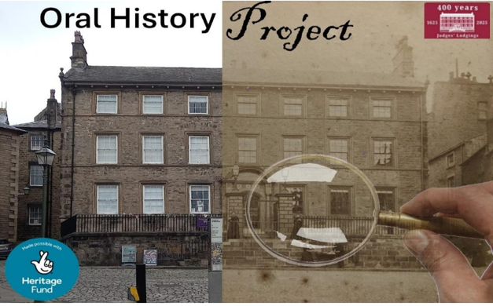


Judges' Lodgings is a Grade 1 listed building and Accredited Museum, owned by Lancashire County Council and manged by Lancashire County Museum Service www.lancashire.gov.uk/museums

